Creating Stories and Epics
Login to JIRA
Go to your project dashboard and Click on Epics
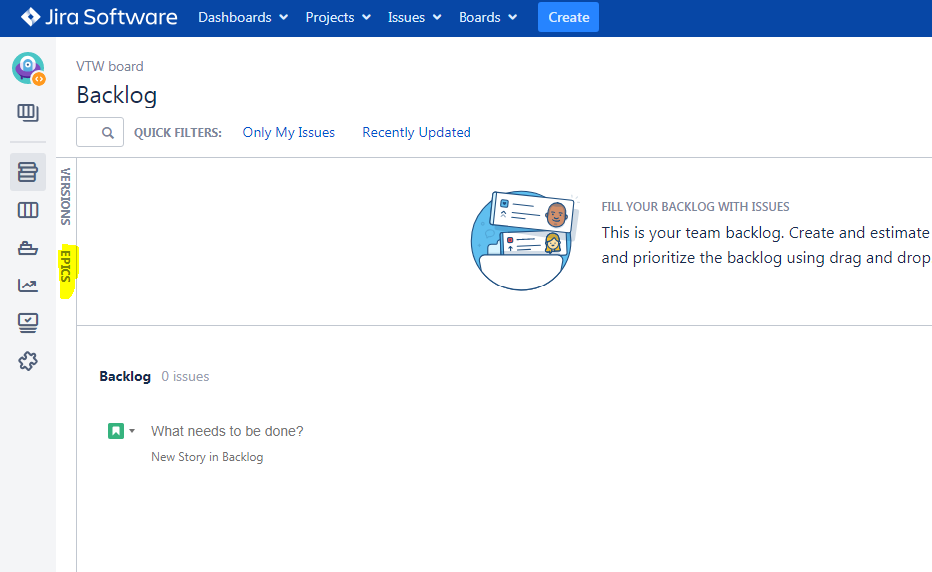

Click on Create Epic
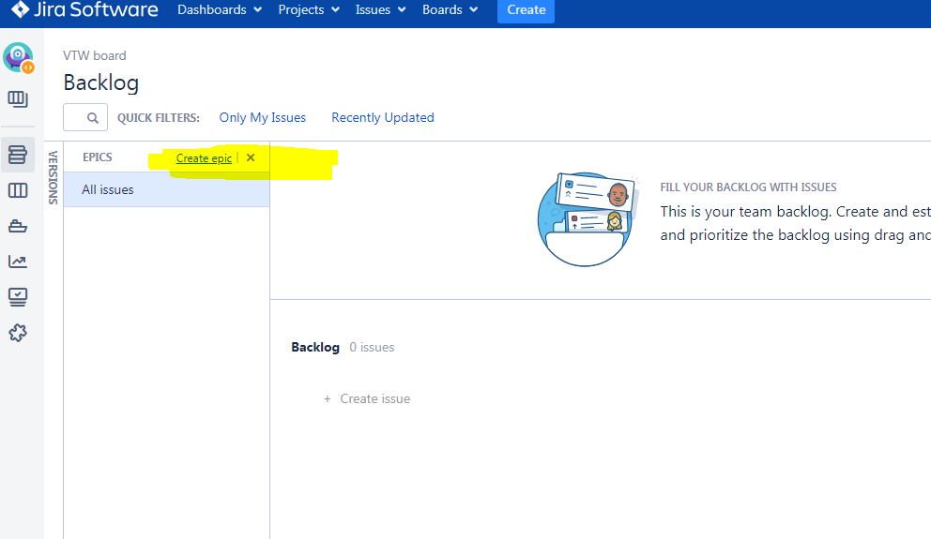

Give Name and Summary and click Create
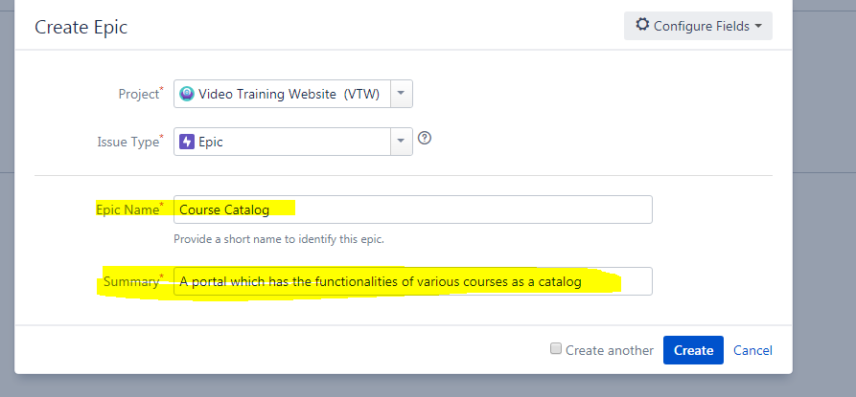

Click on Create issue in epic

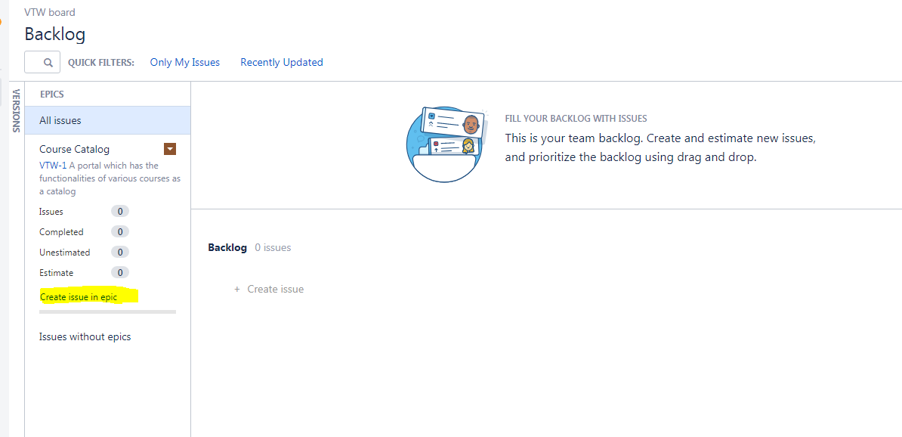

Give Summary, description and click Create
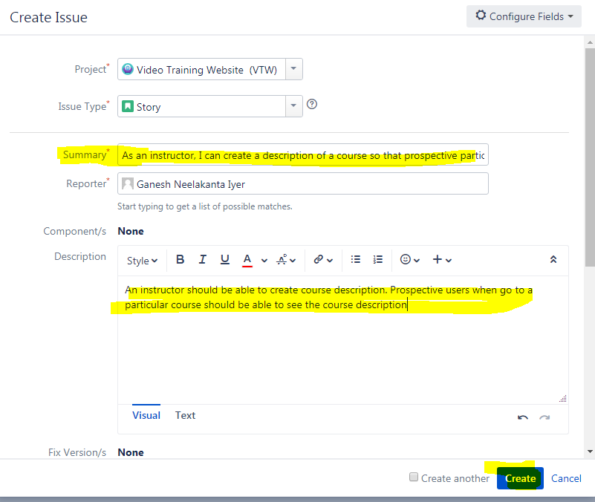
Repeat this process for all epics and stories.
Once you start creating stories and epics, your dashboard will look something like this:
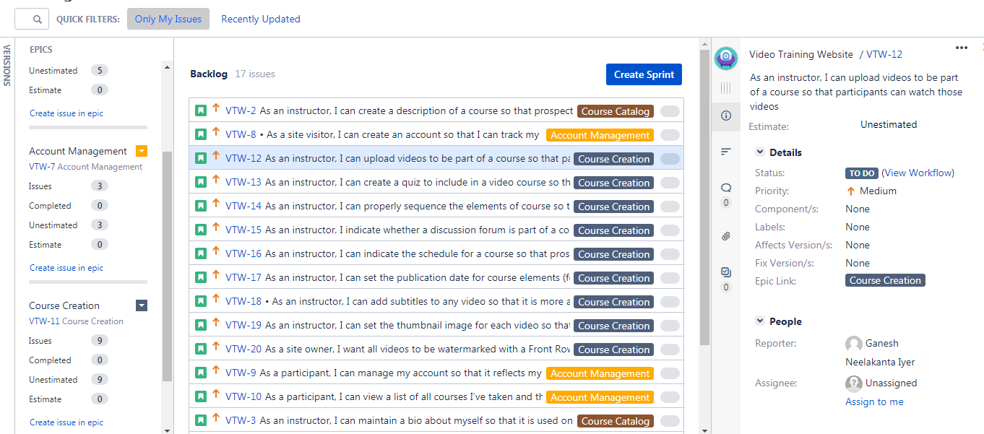

Creating a Sprint

In the project dashboard, click on the button Create Sprint
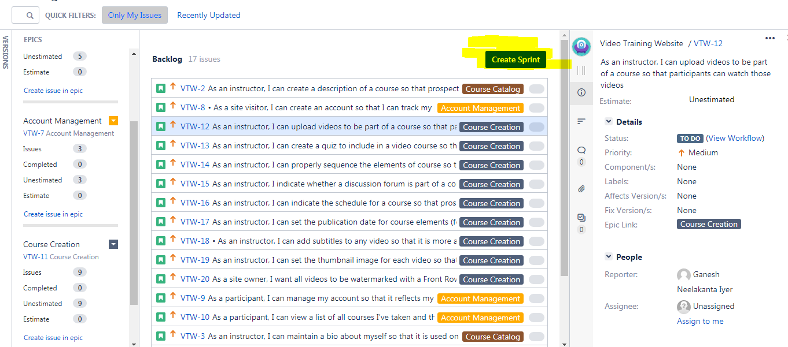
Click on the ” …” and click Add Sprint Goal
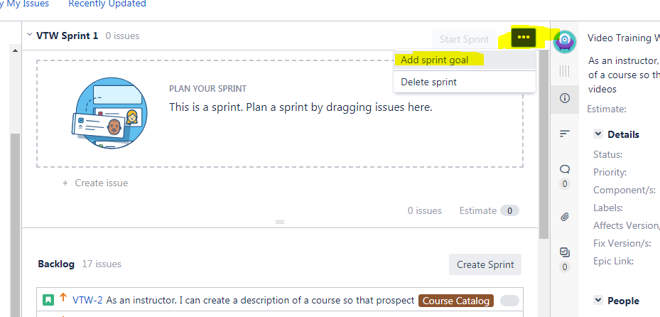

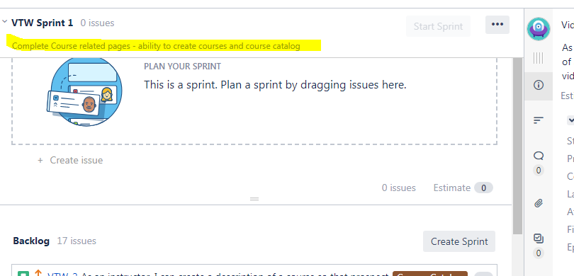

Drag and Drop stories from Product backlog to Spring backlog
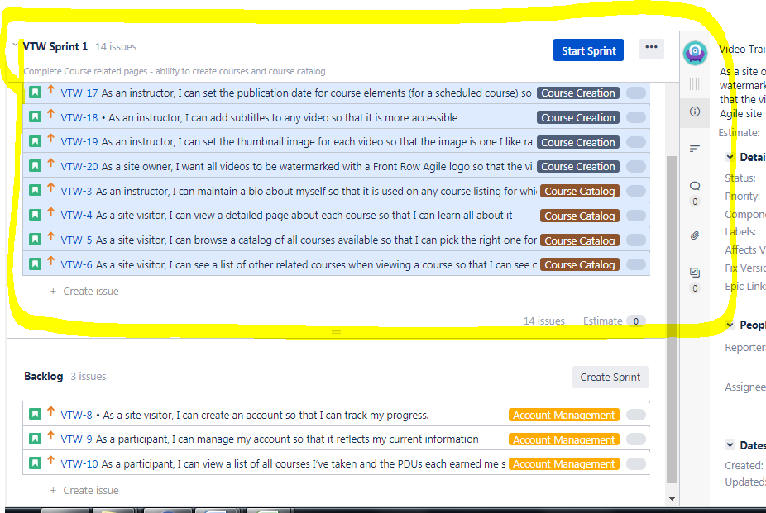

For each story enter the estimates, priorities and other details including assigning each story to one of the team members.
Estimates are essentially story points which say the amount of effort needed to get that work done. A guideline to be followed when estimating story points are:
Effort in hours | Story points
4 | 1
8 | 2
12 | 3
16 | 4
20 | 5
24 | 6
28 | 7
32 | 8
>32 hours effort means split that story in two smaller stories

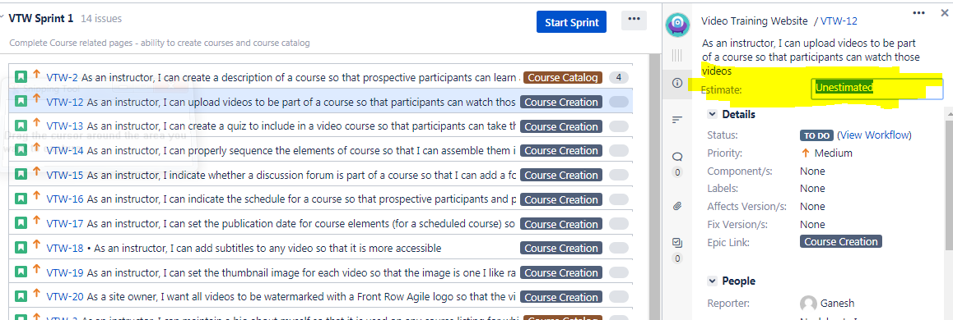
Now lets start the sprint
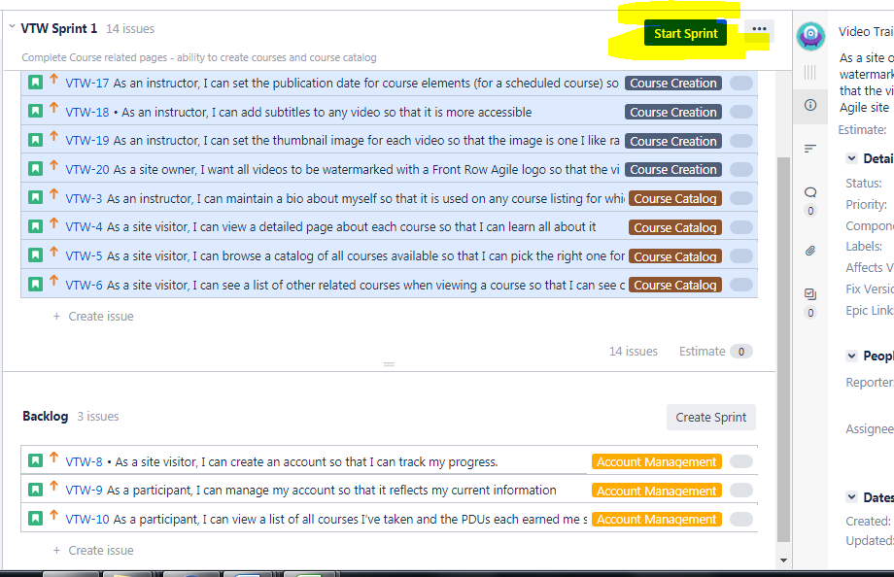

Specify the details and click start
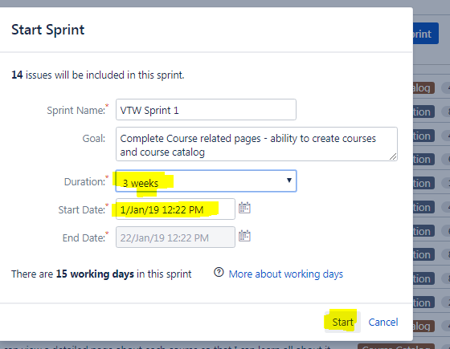
Then you will see your sprint dashboard


